F-32 - F-32 - Manual Clearing

Functionality
This function allows you to clear open items on the customer account. It differs from posting with a clearing transaction or posting with a payment in the following ways:
You do not need to enter a document header
You can only clear open items from one account

Scenario
There are some postings on Customer account (e.g. payment and invoice) that balance to zero, but are not cleared. You want to clear the postings.

Requirements
Not cleared postings on customer account.

Menu Path | Accounting → Financial Accounting → Accounts Receivable → Account - F-32 – Clear
Transaction Code | F-32

1. Double click on F-32 – Clear.

Clear Customer: Header Data

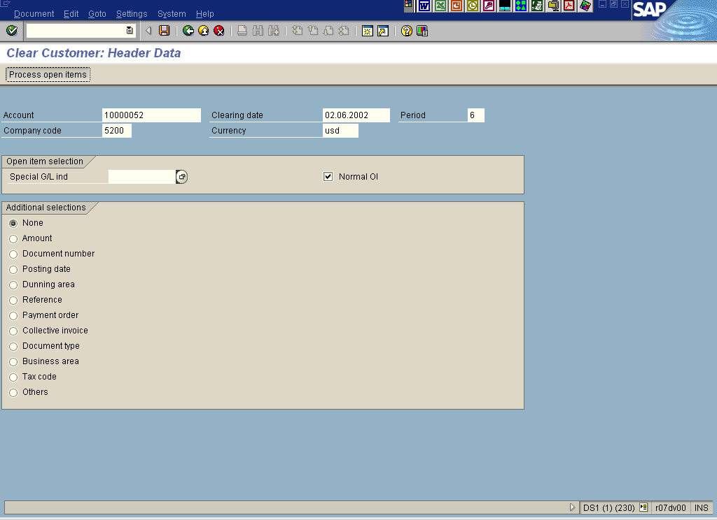

2. Update the following fields:

Field Name | Field Description | Values
Account | Customer account that contains open items to be cleared | Example: 10000052
Clearing date | Clearing entry date. Clearing process always creates a document. The document will be posted with clearing date. | Example: 02.06.2002
Company code | Company code number | Example: 5200
Currency | Code identifying the type of currency used in a transaction or for all transactions pertaining to a specific account | Example: USD

3. To start clearing the open items, click Process open items Button .

 The system will display all not cleared items that fulfill previously entered search criteria.

Clear Customer: Process open items

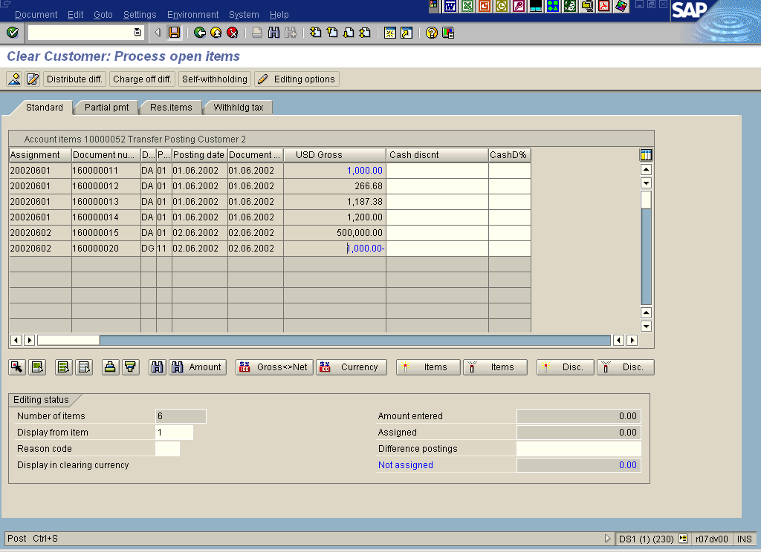

When you display this screen, all open items are selected by default. You want to choose only some of them for clearing. To do so, proceed as follows:

4. Click Select all Button . All open items are now selected.
5. Click Items Button to deactivate all items.
6. Now, you need to select only the items that you want to clear. Double click on the following line items: document number 160000020 and 160000011. The selected items will be highlighted in blue.

Clear Customer: Process open items

7. The field “Not assigned” is equal 0, so the clearing operation can be posted. To complete it, click Save Button..

8. The message bar displays “Document number xxxxxxxxx was posted in company code 5200”. This is the number of clearing document – no “real” posting took place!

Tip: If you want all your open items NOT TO BE SELECTED when you enter the clearing transaction, perform the following steps:

Clear Customer: Header Data

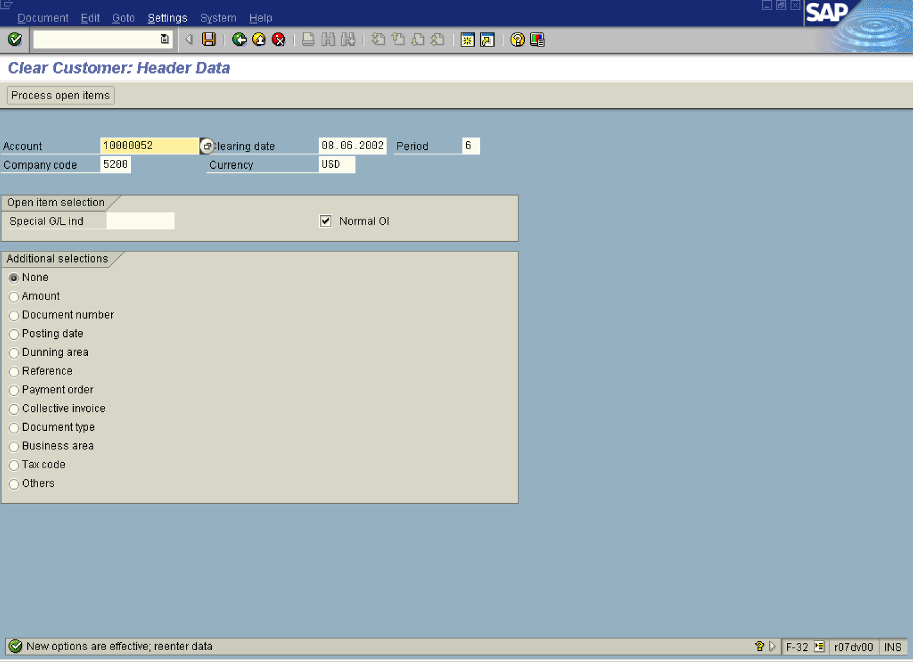

9. On the screen above use the following menu path: SettingsEditing options.

 You need to be authorized to work with "Editing options".

Accounting Editing Options

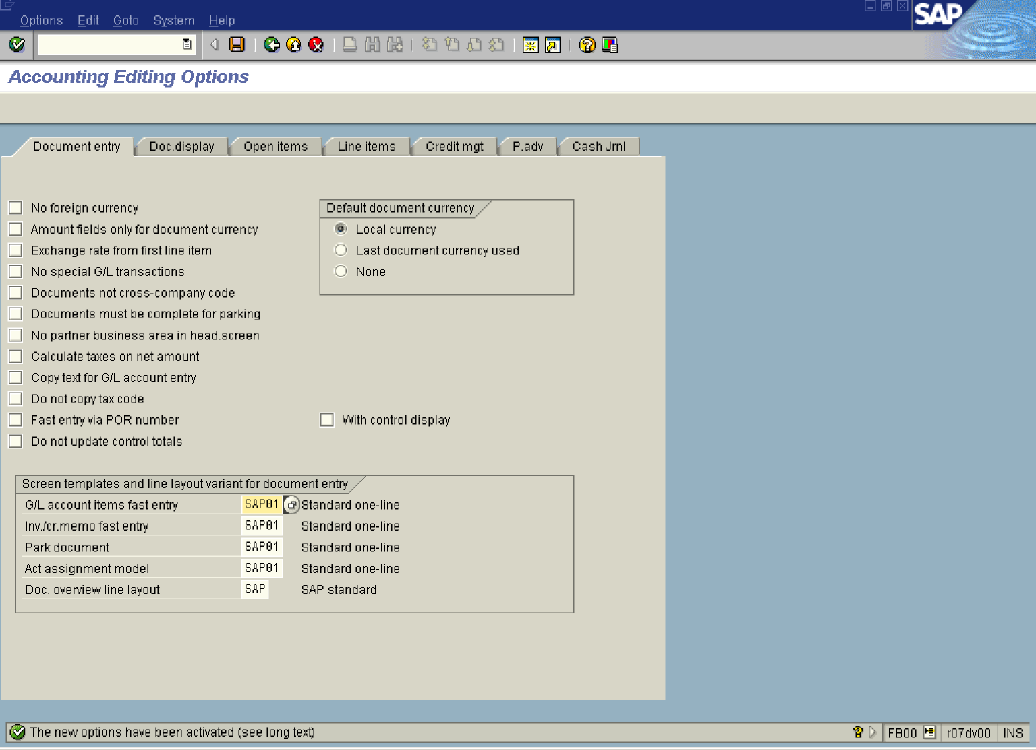

10. Click <tab button> Open items .

Accounting Editing Options

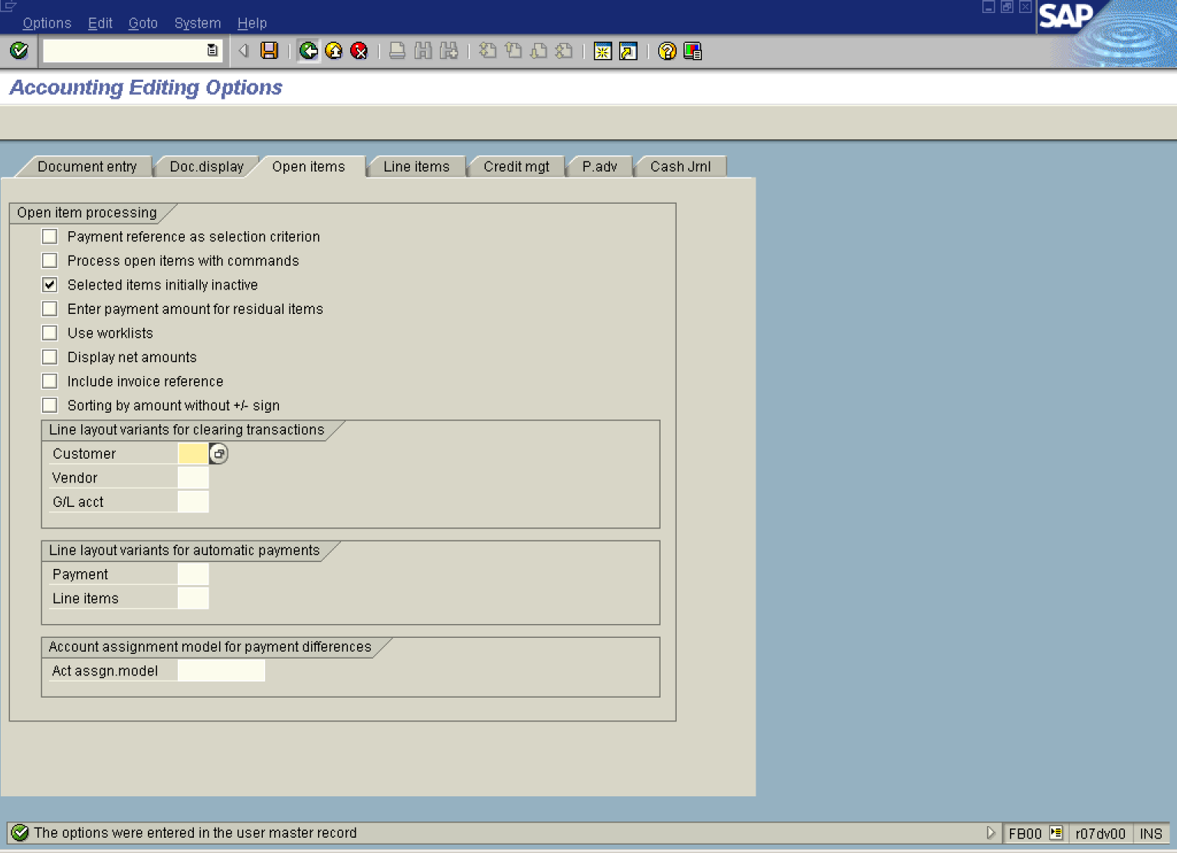

11. Click <checkbox> Selected items initially inactive .
12. Click Save Button.. The settings are now stored in user’s data.
13. Click Back Button . From now on, when you want to clear an account (customer, vendor or GL account), all the items will be initially inactive. You need to click on the selected items to activate them for clearing.

